**“SMART ATTENDANCE SYSTEM”**

**A PROJECT SUBMITTED TO**

**MSBTE, MUMBAI**



**FOR THE DIPLOMA IN**

**COMPUTER TECHNOLOGY**

**BY**

**Mst. Bagal Rohit Ravindrakumar (CM312)**

**Mst. Rokade Rohan Shivaji (CM 328)**

**Mst. Lokare Prajval Dattatray (CM 337)**

**Mst. Pawar Sachin Namdev (CM 352)**

**UNDER THE GUIDANCE OF**

**Prof. Ghalame S. S**



**DEPARTMENT OF COMPUTER TECHNOLOGY**

Shree Pandurang Pratisthan Pandharpur’s

KARMAYOGI POLYTECHNIC COLLEGE

SHELVE, TAL-PANDHARPUR, DIST-SOLAPUR PIN. 413304



This is to certify that the Synopsis report entitled

**“Smart Attendance System”**

**Has been submitted successfully by**,

**Mst. Bagal Rohit Ravindrakumar (CM312)**

**Mst. Rokade Rohan Shivaji (CM 328)**

**Mst. Lokare Prajval Dattatray (CM 337)**

**Mst. Pawar Sachin Namdev (CM 352)**

**Of Third Year Computer Technology**

**In Partial Fulfilment of the Diploma Course in Computer Technology in academic Year 2018-2019 as prescribed by MARASHTRA STATE BOARD OF TECHNICAL EDUCATION, MUMBAI**

**Prof. Ghalame S. S Prof. Ghanawajeer D. J Prof. Dr. Kanase A. B**

**(Project Guide) (Head Of Department) (Principal)**

**DECLARATION**

We hereby declare that the dissertation entitled “Smart Attendance System**”** is successfully completed and written by us has not previously formed the basis for the award of any Diploma in this or any other Board or examining body.

Place: Shelve

Date:

**ACKNOWLEDGEMENT**

At first & foremost with the blessings of Almighty we would like to dedicate this report to **Aai & Baba.** While working on the current dissertation of **“Smart Attendance System*”*** got exposed to a vivid programming platform with due to support of teachers and friends.

We would like to express my heartfelt gratitude to my guide **Prof. Ghalame S. S.** who acted as a source of inspiration in all spheres of my dissertation phase & necessarily providing all resources along with a great platform to accomplish my target. We also thankful to Sir for his constant valuable guidance and encouragement during the course period. Besides his entire busy schedule Sir always gave me enough time to discuss and sort out my queries. With whatever little progress we made, Sir appreciated and constantly guided me towards the next optimum level in the dissertation phase. Apart from technical skills, Sir also introduced professional skills in me we also thankful to our H.O.D. **Prof. Mr. Ghanwajeer D. J.** and project. Co-coordinator **Prof. Mr. Shaikh M. N.** for accepting my studentship.

We would like to acknowledge our Hon. Principal **Dr. Kanase A.B.** Sir for introducing the Diploma (Computer Technology) course in our Institute. Otherwise, it would have been difficult for me to take admission for this course at any other place. We would also like to thank other faculty and staff members and non-teaching staff of my department.

We would like to thank all my batch mates for their help in group learning process. I would like to thank my relatives and friends who helped me with technical and emotional guidance during this tenure. It will be wrathful to close the acknowledgement section conveying a heartfelt thanks to all.

Mst. Bagal Rohit Ravindrakumar (CM312)

Mst. Rokade Rohan Shivaji (CM 328)

Mst. Lokare Prajval Dattatray (CM 337)

Mst. Pawar Sachin Namdev (CM 352)

**INDEX**

|  |  |  |  |  |  |  |
| --- | --- | --- | --- | --- | --- | --- |
| **Sr.No.** | | | | | **Name of Topic** | **Page No.** |
| **1.** | | | | | **Introduction** |  |
|  | | 1.1 | | | Title of project | 6 |
|  | | 1.2 | | | Overview | 6 |
|  | | 1.3 | | | Need of project | 7 |
|  | | 1.4 | | | Related of work | 7 |
|  | |  | | 1.4.1 | Existing system | 7 |
|  | |  | | 1.4.2 | Proposed system | 7 |
|  | |  | | 1.4.3 | Methodology | 7 |
|  | |  | | 1.4.4 | Hardware requirement | 8 |
|  | |  | | 1.4.5 | Software requirement | 8 |
|  | |  | | 1.4.6 | Characteristics | 8 |
|  | | 1.5 | | | SDLC | 9 |
| **2.** | | | | | **Software Requirement Specification** |  |
|  | 2.1 | | | | Purpose | 10 |
|  | 2.2 | | | | Scope of project | 10 |
|  | 2.3 | | | | Overview of document | 10 |
| **3.** | | | | | **Design** |  |
|  | 3.1 | | | | Overall description | 11 |
|  | 3.2 | | | | Product features | 11 |
|  | 3.3 | | | | Characteristics | 11 |
|  | 3.4 | | | | Operating Environment | 12 |
|  |  | | 3.4.1 | | Platform Used | 12 |
|  |  | | 3.4.2 | | Front End | 12 |
|  |  | | 3.4.3 | | Language | 12 |
|  |  | | 3.4.4 | | Software requirement | 12 |
|  |  | | 3.4.5 | | Hardware requirement | 12 |
|  | 3.5 | | | | Design Implementation Constraints | 13 |
|  |  | | 3.5.1 | | Object diagram | 13 |
|  |  | | 3.5.2 | | Class Diagram | 13 |
|  |  | | 3.5.3 | | Data Flow Diagram | 14 |
|  |  | | 3.5.4 | | Use Case Diagram | 14 |
|  |  | | 3.5.5 | | Sequence Diagram | 14 |
|  |  | | 3.5.6  3.5.7 | | ER diagram  DFD | 15  15 |
|  | 3.6 | | | | Snapshots | 16 |
|  | 3.7 | | | | User documentation | 19 |
|  | 3.8 | | | | Assumption and dependencies | 19 |
| **4.** | | | | | **System features** | 19 |
| **5.** | | | | | **External interface requirement** |  |
|  | 5.1 | | | | User interface | 20 |
|  | 5.2 | | | | Hardware interface | 20 |
|  | 5.3 | | | | Software interface | 20 |
|  | 5.4 | | | | Features | 20 |
| **6.** | | | | | **Other Non-Functional Requirements** |  |
|  | 6.1 | | | | Performance requirement | 21 |
|  | 6.2 | | | | Software quality attributes | 21 |
| **7.** | | | | | **Testing** |  |
|  | 7.1 | | | | Content Testing | 22 |
|  | 7.2 | | | | Interface testing | 23 |
|  |  | | 7.2.1 | | Interface testing strategy | 23 |
|  | 7.3 | | | | Usability testing | 23 |
|  | 7.4 | | | | Compatibility testing | 23 |
|  | 7.5 | | | | Testing Methods | 23 |
|  |  | | 7.5.1 | | Acceptance testing | 24 |
|  | 7.6  7.7 | | | | Bug regressions  Enhancement | 24  24 |
| **8.** | | | | | **Conclusion** | 24 |
|  | 8.1 | | | | Future Scope | 25 |
| **9.** | | | | | **References** |  |
|  | 9.1 | | | | Implant training | 25 |
|  | 9.2  9.3 | | | | E-Books  Reference links | 25  25 |
|  |  | | | |  |  |
| **10.** | | | | | **Abbreviations** | 26 |

**ABSTRACT**

Today attendance is most important for colleges, universities or any organization According to observations Information and Communication Technology (ICT) attendance plays a very vital for students as well as faculty. This project is based on SMART ATTENDANCE SYSTEM. It manages the student information, their attendance. It also keeps result records of all the information regarding students those who are in college. It should the attendance of students, their clock in and clock out time of student.

The last few years have seen high requirement for attendance management system. In this paper we present a python application to make it easier for a faculty to mark attendance. This application will assist him/her in marking attendance easily without any difficulty and even without even wasting time for marking attendance manually. This the main objective is to design the python application which gives the all information students attendance. The computer system is used for to see the implementation by using VS code software, python 3.6.0. The software design is implementation has a biggest priority during develop this software. Python, Excel and XML languages are used for develop python software.

**Chapter 1**

**Introduction**

Smart attendance system software is a python 3.6 PyQt5 based software for colleges/organizations to know what attendance of which student in college these are clearly known in this software we will get the information about the attendance student wise of that college which is helpful for the faculty. We also added information of the clock in and clock out time of student. We’ve also shown a square on screen to show if the face of the student is recognized or not and name of that student under the square. We have proposed this software in English language. This project mainly deals with the design and implementation of python software with the help of python 3.6.0 on VS code platform “SMART ATTENDANCE SYSTEM" which is used for attendance related information, which is helpful for the faculty and college/organization.

The highlighted features of this project includes:-

* Identify real-time face of student.
* Collect information of particular student in colleges.
* Software design implementation.
* The main objective is to design the python software which gives the all about information of attendance of student.
* The computer system is used to see the implementation by using VS code software.
* Python 3.6.0, PyQt5 & XML are used for develop a software.
* This paper describes an application of the presented project which is based on the python3.6.0 platform.

**1.1 Title of the project:-**

**Smart attendance system.**

**1.2 Objectives:-**

1. To provide all related information about the attendance of the students.

2. To provide clock in and clock out time of the students.

3. To provide attendance related information about particular student to faculty of the college.

4. To reduce the manual work.

**1.3 Need of project:-**

In the educational field, if we consider today's situation, attendance marking of students is the most important part as this software provides all the information about students presenty, his/her clock in and clock out time, it also shows his/her name

**1.4 Related work:-**

**1.4.1 Existing System:-**

* In market different type of attendance management are available
* But there is no college using Facial recognizing attendance marking system.

**1.4.2 Proposed System:-**

We have covered some drawbacks of existing system for non-facial attendance system .We have converted this manually work into automatic attendance marking using facial recognition. This software has a various features than existing system. As like existing software, our software Smart Attendance System provides all the details about attendance of students.

Smart attendance system is python based application which adds more features like:

1. Overcomes the dependency of a person handling all the activities of marking attendance.

2. Faculty could easily get the attendance marked and get his/her work reduced.

3. It also shows the name of student, his/her clock in and clock out time.

4. Easy Excel sheet generation.

**1.4.3 Methodology: -**

This section of the report explains about what we going to do and how are we going to do it. We will be following incremental model for the completion of this project which is discussed by below briefly.

**1.4.3.1 Incremental Development Model: -**

Incremental development is based on the idea of developing an initial implementation, exposing this to user commit and involving through several versions until a complete system has been developers.

**1.4.4 Hardware Requirement: -**

* CPU-Intel(R) Core (i5).
* RAM-4GB
* Hard Disk-1TB.

**1.4.5 Software Requirement: -**

* Python 3.6.0, VS code.
* MS Access (Backend).

**1.4.6 Characteristics: -**

* User Friendly.
* Data kept Secure.
* Automatic face detection.
* Show name of that particular student.
* Shows clock in and clock out time of that particular student.

**1.5 SDLC:-**

**1.5.1 Requirement & Analysis Phase:-**

First and important phase of SDLC for the success of software. This phase includes communication between project stakeholder, end users and project team, as requirements (both functional and non-functional) are captured from clients.

**1.5.2 Design phase:-**

In design phase of SDLC, based on requirement captured in SRS, architecture design is proposed for project and captured in design document.

This phase of SDLC include:-

-Partition of requirements into hardware and software system.

-Designing system architecture.

**1.5.3 Development Phase:-**

This is the longest phase of SDLC includes:-

-Actual code gets written.

-Demonstration of work accomplished to Business analyst for future modification as per requirement.

-Unit testing is performed i.e. Verification of code as per requirements.

**1.5.4 Testing Phase:-**

The testing strategy is involved in almost all stages of SDLC. However this phase of SDLC refers to the only testing of system where bugs/defect of the system are reported, tracked or fixed. The system/project is migrated to a test environment and different type testing is performed like functional, integration system and acceptance. This is performed until the project reaches the quality standard as specified in SRS.

This phase of SDLC includes:-

System is tested as whole as well as different types of testing to report and fix bugs.

**1.5.5 Deploy & Maintenance Phase:-**

In this phase of SDLC, once the system is tested, it reply to go live. The system may be first testing .This phase of SDLC include:

* System is ready to be delivered.
* System is installed and put into use.
* Correction of errors that were not caught before.
* Improving system and utility enhanced system in data center.

**1.5.6 SDLC Models:-**

* Waterfall Model
* Iterative & Incremental Model
* Spiral Model
* Agile Development

**Chapter 2**

**SRS (Software Requirement Specification)**

**2.1 Purpose:-**

The purpose of this document is to present detailed description of the python software “Smart attendance system software”. It will explain the purpose and features of this software, what the application will do, the constraints under which it must operate and how the system will react to external stimuli. This document is intended for both stakeholders and the developers of this software.

**2.2 Scope of Project:-**

This Software will work for an institute for marking attendance .Faculty will mark their attendance of students as per their feasible time. Activities like face recognizing, pattern matching of the faces, identifying the names, getting the clock in and clock out time. Creations done in the system by the System Operator will be maintained in the form of tables for auditing and maintaining the integrity of the system.

**2.3 Overview of Document:-**

The smart attendance system allows authorized students to be marked for the attendance of that particular college.

It can be used in various educational institutes, universities etc. across the global and simplifies working of attendance.

**Chapter3**

**Design**

**3.1 Overall Description:-**

The section of the report should put perspective with other related software product is independent and totally self-contained it should be so stated here.

Python software and in there is information it can be helpful for all faculty who use this software properly. It is helpful to all colleges/universities/organizations.

This should also describe how the software operates inside various content.

1. System Interface
2. User Interface
3. hardware Interface
4. Software Interface
5. Memory
6. Operations.

**3.2 Product features:-**

-Python Platform software.

-User friendly/Python software.

**3.3 Characteristics:-**

-Easy to understand.

-Interactive GUI for python software.

-It's very easy to operate. Time and effort saving process.

-Information related Application in English Language.

-It is better to use as compare to any software related to this software on the Google.

**3.4 Operating Environment:-**

**3.4.1 Platform used:-**

VS code

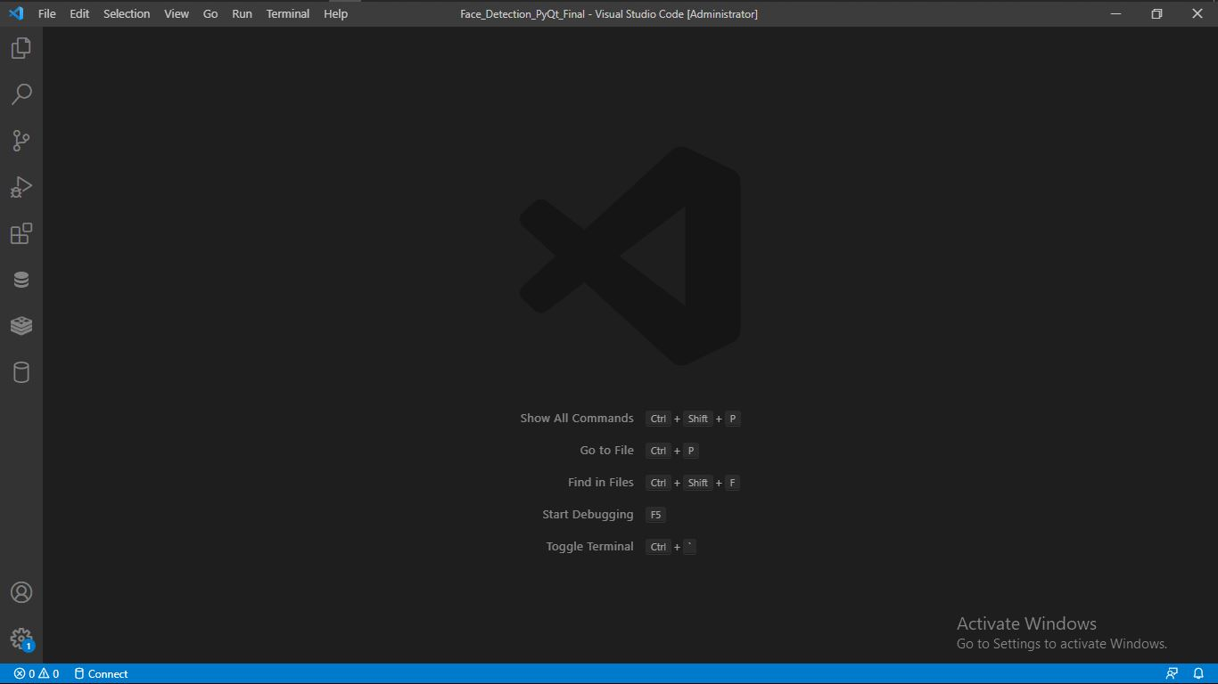

*Figure. VS code start page image*

Visual Studio Code is a lightweight but powerful source code editor which runs on your desktop and is available for Windows, macOS and Linux. It comes with built-in support for JavaScript, Typescript and Node.js and has a rich ecosystem of extensions for other languages (such as C++, C#, Java, Python, PHP, Go) and runtimes (such as .NET and Unity).

**3.4.2 Front End: -** PyQt5**,** XML

**3.4.3 Language:-**Python

**3.4.4 Software Requirements: -** VS code software, MS access for Database.

**3.4.5 Hardware Requirements**: - Data-Cable, Personal Computer/Laptop, Internet.

**3.5 Design Implementation Constraints:-**

**3.5.1 Dataflow Diagram: -**

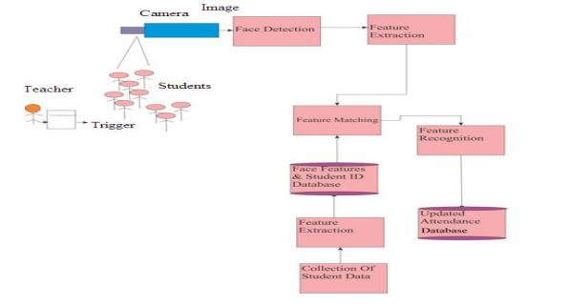

*Figure. Data flow diagram*

**3.5.2 Class Diagram:-**

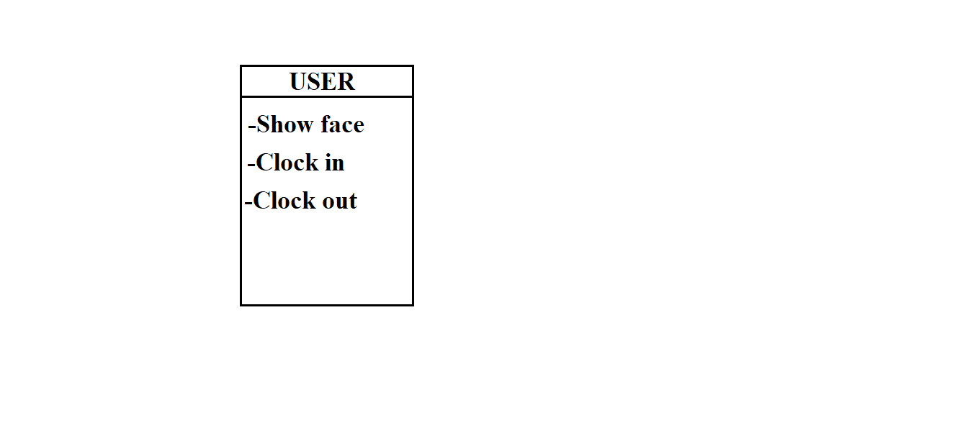

*Figure. Class diagram*

**3.5.3 Use case Diagram:-**

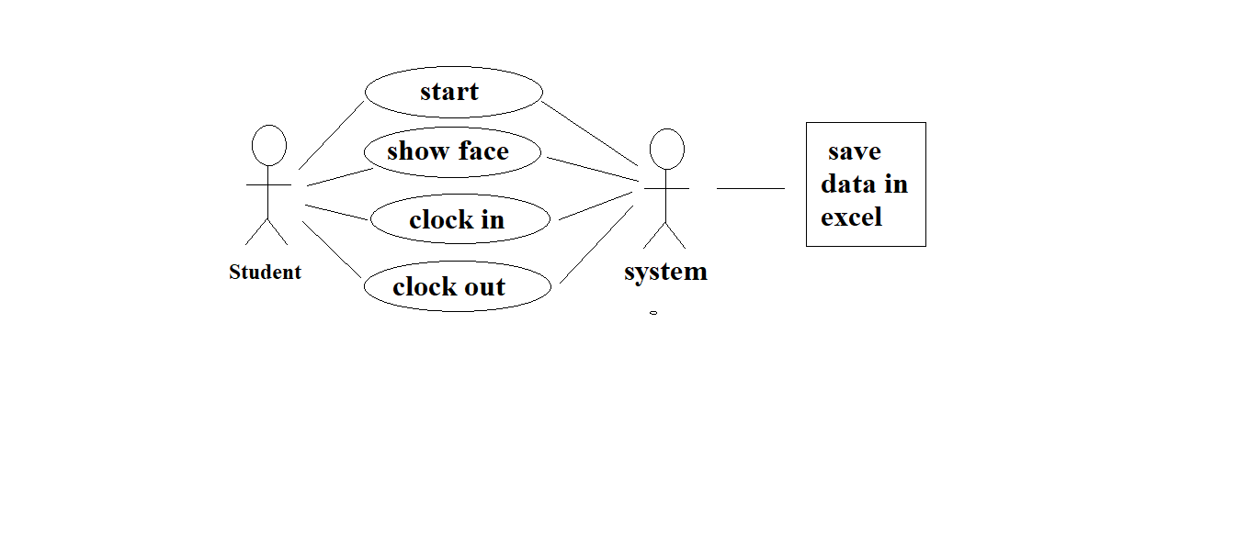

*Figure. Use-Case diagram*

**3.5.4 Sequence Diagram:-**

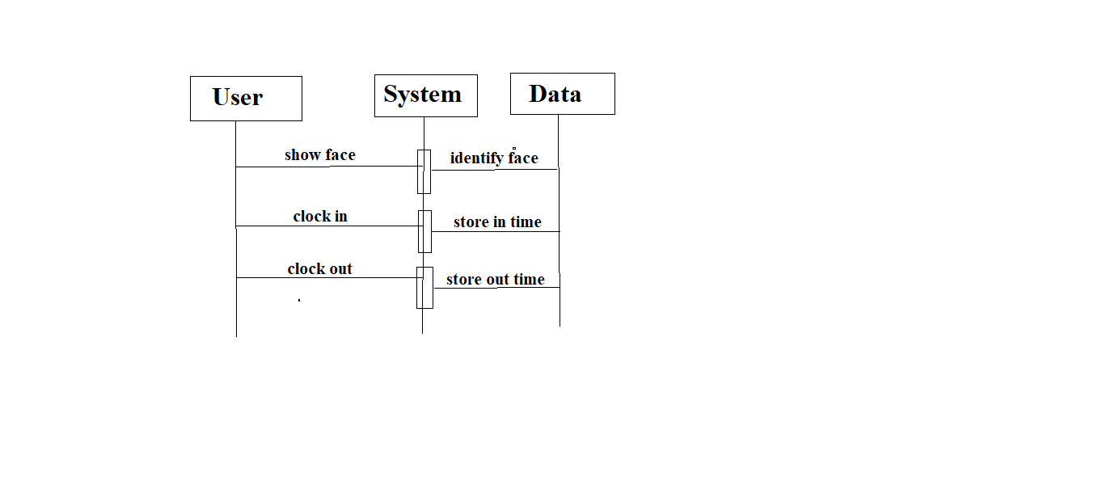

*Figure. Sequence diagram*

**3.5.5 ER Diagram:-**

**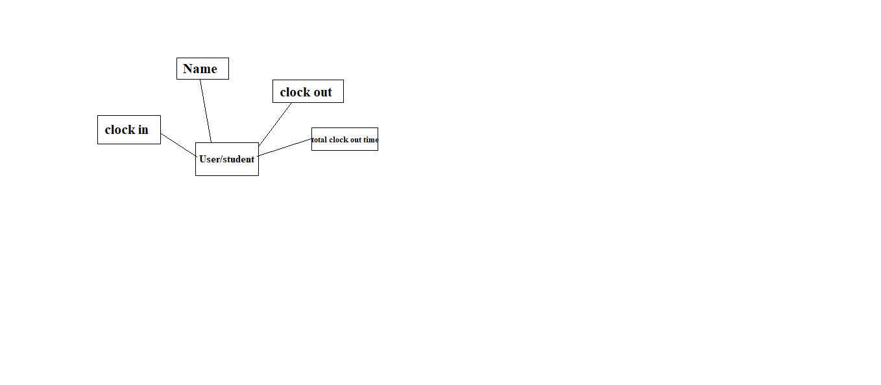***Figure.ER diagram*

**3.5.6 DFD level 0:-**

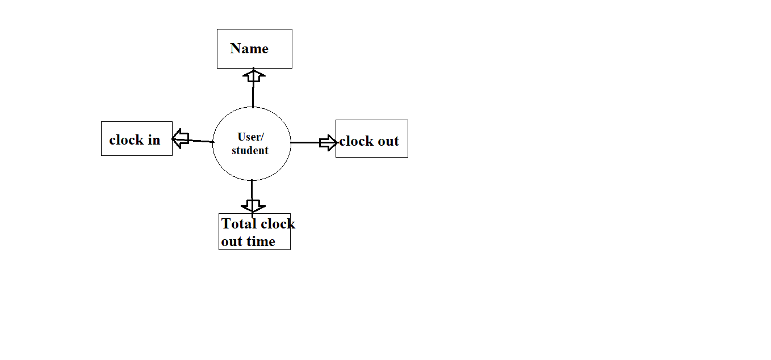

*Figure. DFD Level0 diagram*

**3.6 Snapshots:-**

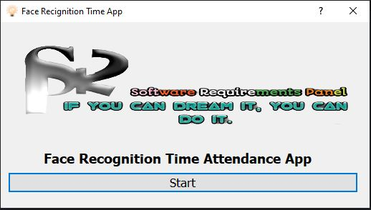

*Figure. Main screen*

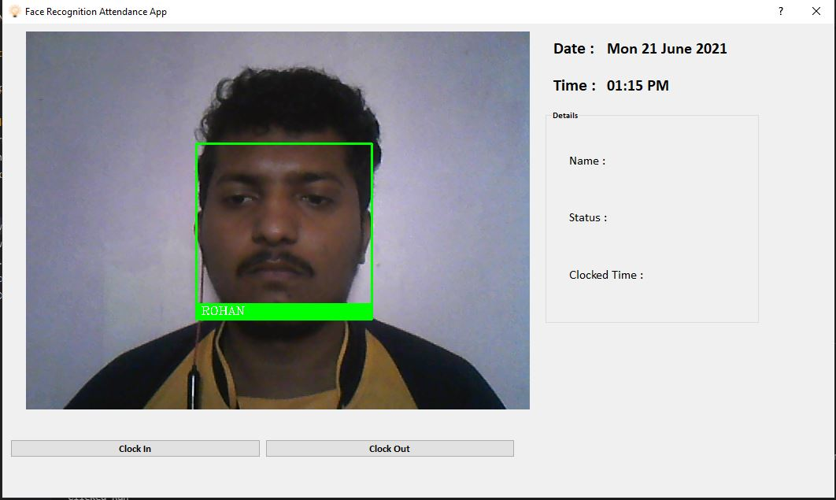

*Figure. Output window screen*

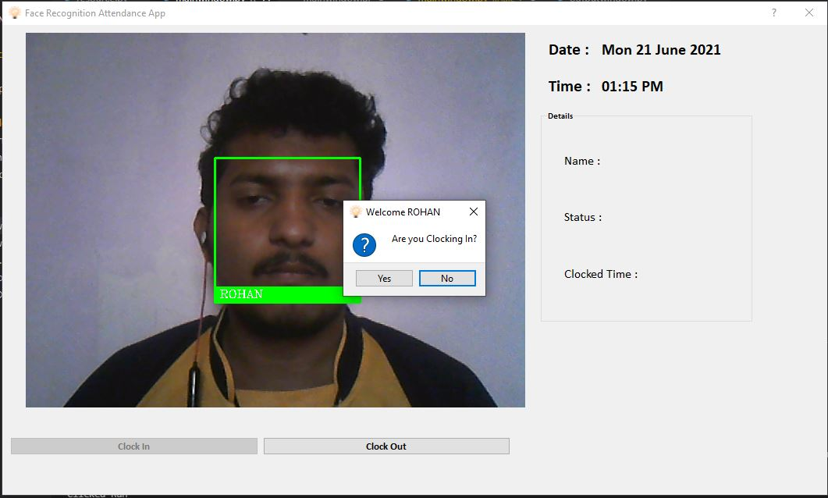

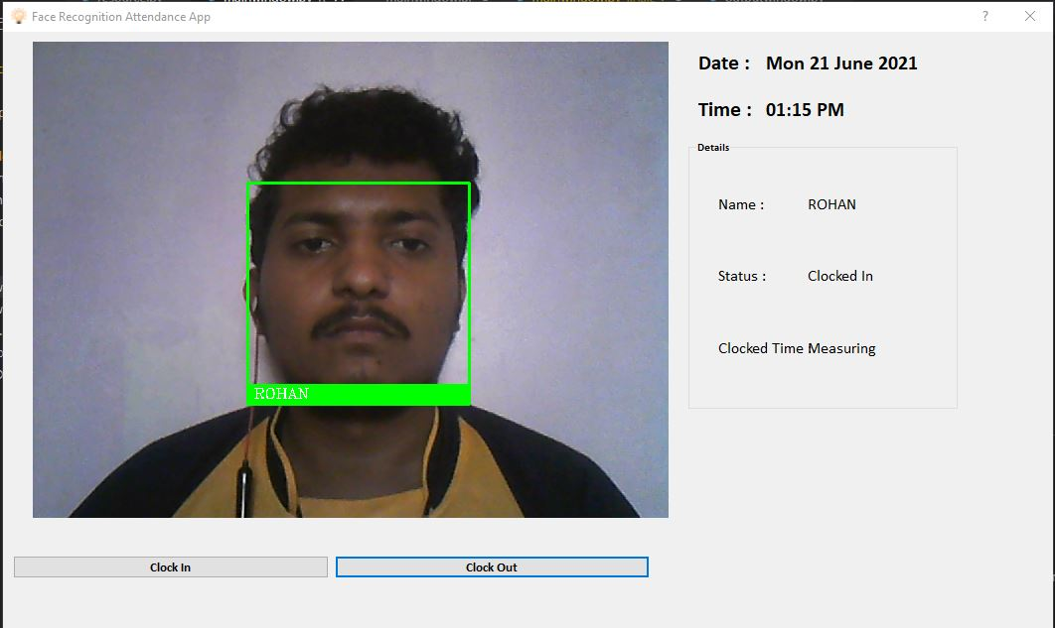*Figure. Clock in screen*

*Figure. Clocked in screen*

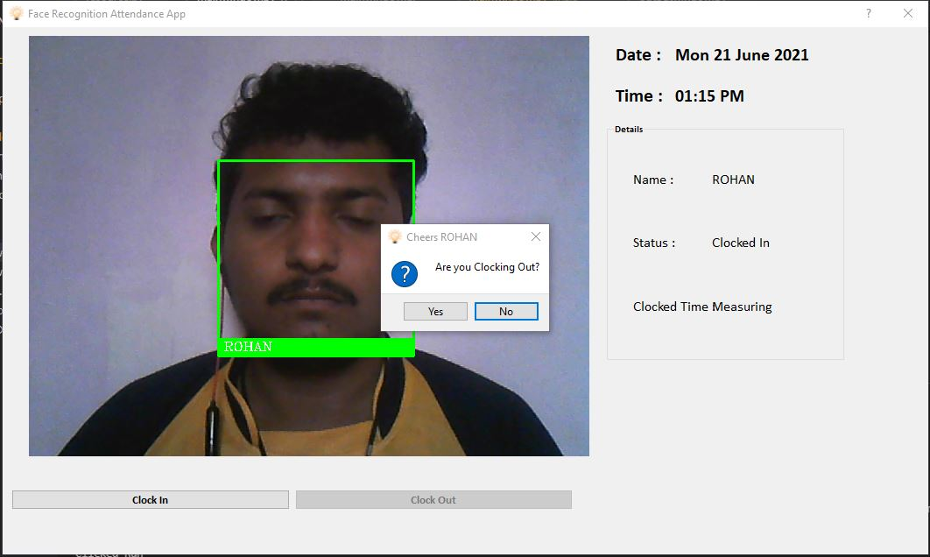

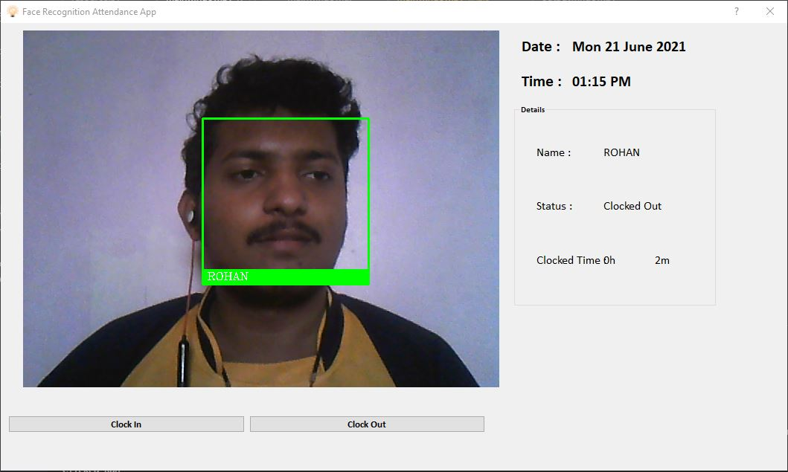*Figure. Clock out screen*

*Figure. Clocked out screen*

**3.7 User Documentation:-**

A user manual to give the detailed information about the software. It is handling the software and help to overcome the problem that may occur at the time of using project.

We provide python software thought our personal drive link and Registration Documentation for legal use.

We also provide upgrade for reliable software.

**3.8 Assumption and Dependencies:-**

Android Application is of required quality.

All drastic bugs receive immediate attention from development team.

Functionality is deliverable to schedule.

All Service agreements will be met.

All documentation will be up to date and delivered to the system team.

**Chapter 4**

**System Features**

This python software is totally information based. It is very useful to all faculty for marking the attendance of students in colleges.

-It is cost effective feature.

-It is also used for marking attendance using facial recognition of students who are in that college/universities/organization.

-It is easy to understand.

**Chapter 5**

**External Interface Requirements**

**5.1 User Interfaces:-**

We will make use of computer system. The user interface of software will be designed as shown in user interface concept. The smart attendance system software will provide Graphical User Interface to attract user.

**5.2 Hardware Interface:-**

In this project we had used following hardware:-

-Computer system/laptop

-Data-Cable

-Personal Computer/Laptop (for back up)

**5.3 Software Interfaces:-**

In this software project we will use python 3.6.0, VS code and MS access Database for development purpose.

Python built in dlib, face-recognition designed especially for development of software’s like face recognition. It is available for download on Windows and Linux based Operating System.

**5.4 Features:-**

-dlib, face-recognition build support.

-Python-specific refactoring and quick fixes.

**Chapter 6**

**Other Non-Functional Requirements**

**6.1 Performance Requirements:-**

The proposed system that we had developed python software. This application includes information about attendance, clock in and clock out time related.

**Advantages:-**

1. Easy to handle this software.

2. It consume less time.

3. It gives directs information from that students attendance.

**6.2 Software Quality Attributes:-**

**-**Accessibility

-Accuracy

-Debugablity

-Correctness

-Durability

-Reliability

-Scalability

**Chapter 7**

**Testing**

Testing is necessary in order to provide the facilities to the customers like the delivery of high quality products or software application which requires lower maintenance cost and hence results into more accurate, consistent and results.

This project has tested successfully. The project is very easy to handle and use our project is fulfillment the customer requirements and satisfaction.

**-What system testing is required?**

System testing is a type of testing to the behavior of a complete and fully integrated software product based on the software requirements specification (SRS) documents.

The main focus of this testing is to evaluate Business/Functional/End user requirements.

**-Volume Testing:-**

Try to create as much record as possible to verify that the hardware and software is functioning correctly.

**-Stress Testing:-**

The purpose of stress testing is to prove that the system is not functioning properly is under peak load.

**-Usability Documentation:-**

This test is verify user friendly nature of the system. The user uses the system to see whether it run smoothly.

**7.1. Content Testing:-**

Errors in software content can be as trivial as minor typographical errors as incorrect information, improper organization or validation of intellectual property laws. Content testing attempt to uncover this and many other problems before the user encounter them.

There are three types of objectives-

-To uncover syntactic errors in text-based documents, graphical representation and other media.

-To uncover semantic errors in any content object represented as navigation.

-To find errors in organization or structure or contents that is presented to the user.

**7.2. Interface Testing:-**

Interface design model is reviewed to ensure that generic quality criteria established for all user interfaces have been achieved and that application interface design issue has been properly addressed.

**7.2.1. Interface Testing Strategy:-**

A test strategy is an outline that describes the testing approach of the software development life cycle .It is created to uniform project managers, testers and developers about some key issues of the testing process.

To overall strategy of interface testing is to uncover errors to the related specific interface mechanism. Uncover errors in the way the interface implements the semantics of navigation, application functionality, or content display. To accomplish this strategy, a number of objectives must be achieved.

**7.3 Usability Testing:-**

Usability test may be designed by python Engineering team. Define a set of usability testing categories and identify goal for each.

Design test that will enable each goal to be evaluated.

Select participants who will conduct test. Instrument participant's interaction with python software testing is conducted.

Develop a mechanism for assessing the usability of the python software.

**7.4 Compatibility Testing:-**

Python software must operate within environment that differs from one another. Different computer, display devices, OS, browser and network connection speed can have significant on Android, different results, regardless of the degree of HTML standardization within the Python software.

The python engineering team drivers a series of compatibility, validation test, performance tests and security test.

**7.5 Testing Methods:-**

Testing presents an interesting anomaly for the software engineering actives, the engineer attempts to build software from an abstract concept to a tangible products. Now come testing.

The software that has been build, infect testing is the one step in destructive rather than constructive.

**7.5.1 Acceptance Testing:-**

If software is developed as a product to be used by many customers, it is impractical to perform formal acceptance test with each one. Most software products builders use process called alpha and beta testing to uncover errors that only the end user seems able to find. The alpha test is conducted at the developer's side by a customer. The software is used in a natural setting with the developer's "looking over the scheduler" of the users and recording errors and usage problem. Alpha test is conducted in a controlled environment. The beta conducted at one or more customer sites by the end user of the software. Unlike alpha testing, the developer is generally not present. Therefore the beta developer is a live application of software in an environment that cannot be controlled by the developer.

**7.6 Bug Regression:-**

Bug Regression will be a central tenant throughout all testing phases. When severity 1 bug fails regression, adopters testing team should also put out an immediate email to development team.

The test lead will be responsible for tracking and reporting to development and product management the status of regression testing.

**Chapter 8**

**Enhancements**

This python software is easy to understand to the student because our project design is very simple. The GUI of our project is easy.

**Chapter 9**

**Conclusion**

**9.1 Conclusion:-**

Different software’s are developed and used by colleges/universities/organizations for their specific purpose. All this software’s have different usage as per its functionalities but, in this project we have developed python software for faculties which provide information about attendance of students in that college. It provides information about attendance of students attending the college lectures physically and create the excel sheet data of students attendance, their clock in and clock out time out of lectures for physical college lectures attendance.

**9.2 Future Scope:-**

This application will be useful for all the colleges/universities/organizations for getting automatically attendance marked of the students using facial recognition information about the marked attendance of the students to reduce the manual work.

This software is very simple to handling for the faculties. Teachers can use this software for their day-to-day life for college use.

**Chapter 10**

**References**

**10.1 Implant training:-**

Internshala training for programming with python.

**10.2 E-Books:-**

-Provided by internshala course.

-PyQt5, dlib, face-recognition pdf books

**10.3 Reference links:-**

<https://pypi.org/project/face-recognition/#description>

https://www.google.com/amp/s/www.geeksforgeeks.org/opencv-python-tutorial/amp/

https://youtube.com/playlist?list=PLCC34OHNcOtpmCA8s_dpPMvQLyHbvxocY

**Chapter 11**

**Abbreviations**

* SDLC:-Software Development Life Cycle.
* GUI:-Graphical User Interface.
* SRS:-Software Requirement Specification.
* OS:-Operating System.
* XML:-Extended Mark-up Language.
* HTML:-Hyper Text Mark-up Language.
* MS: - Microsoft.
* WWW:-World Wide Web.
* DFD: - Data Flow Diagram.
* ICT: - Information and Communication Technology.